JIRA TASK PROGRESS

1. Task Created → Goes to TO DO
- Initially, all new tasks are placed in the TO DO column.
- This means the task is not started yet.
Example: Requirement received, work not begun.

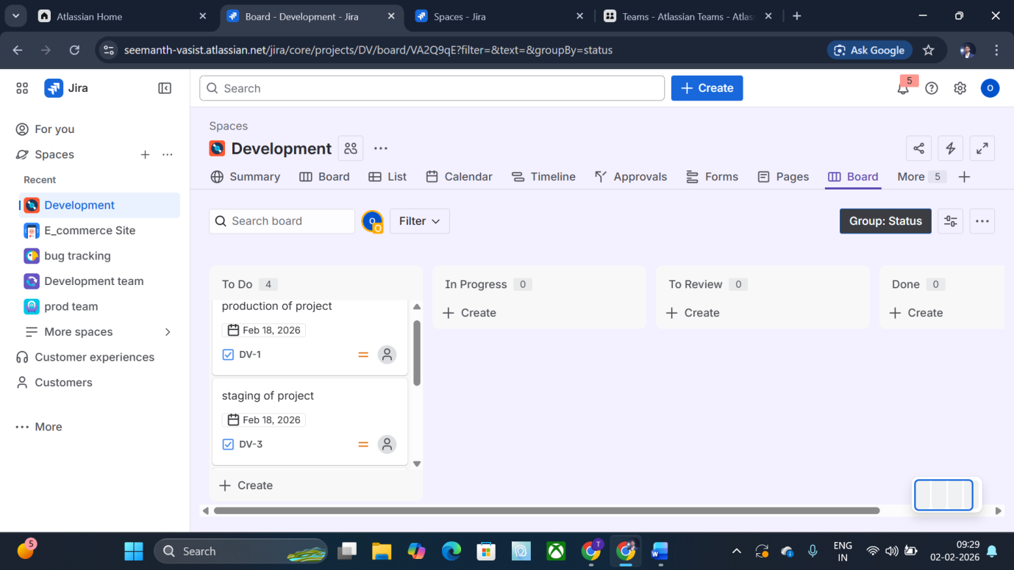

2. Start Working → Move to IN PROGRESS
- When you begin working on a task, drag it into IN PROGRESS.
Meaning: Development or implementation is happening.

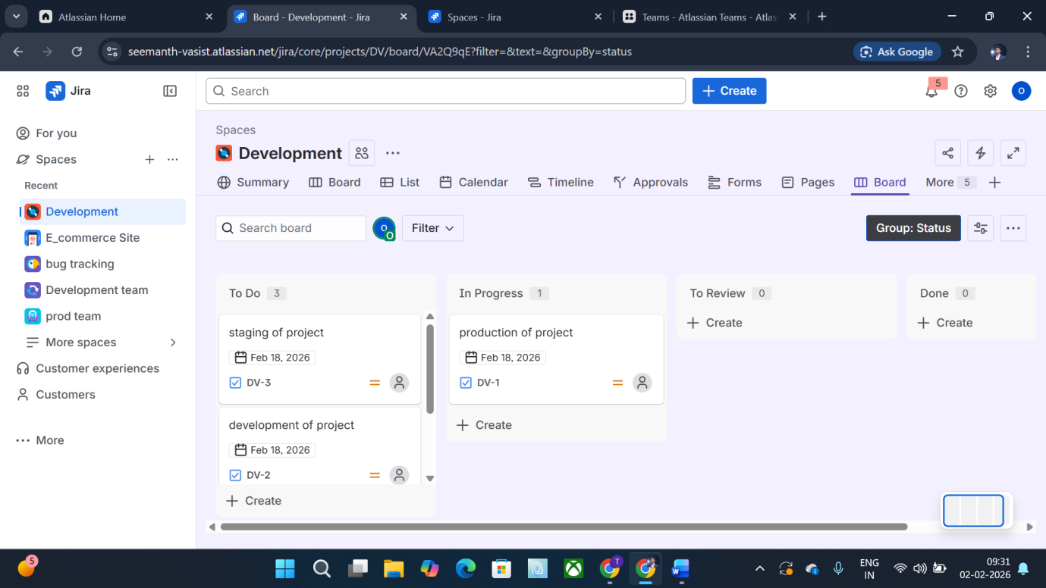

3. Work Completed → Move to REVIEW (or QA)
- After finishing the task, it should be moved to REVIEW (or Testing/QA).
Meaning: Work is done, waiting for verification.

4. If Changes Needed → Move Back to IN PROGRESS
- If reviewer finds issues or requests changes, the task goes back to IN PROGRESS.
Meaning: Rework is required.

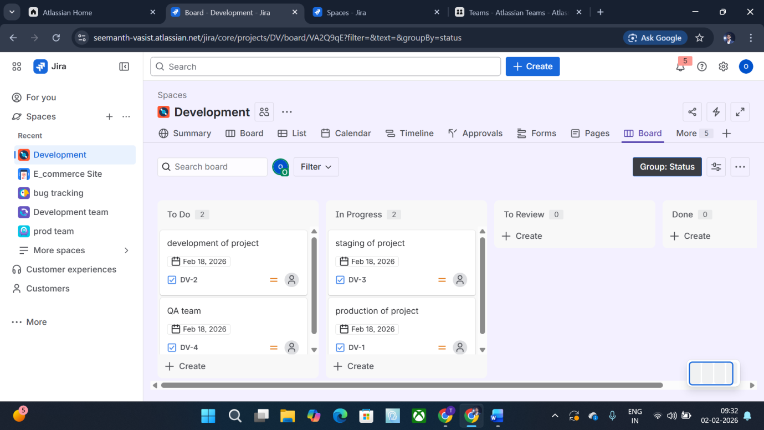

5. After Fixing → Move Again to REVIEW
- Once corrections are done, send it again for review.
This step is correct, but your document repeats it without explanation.

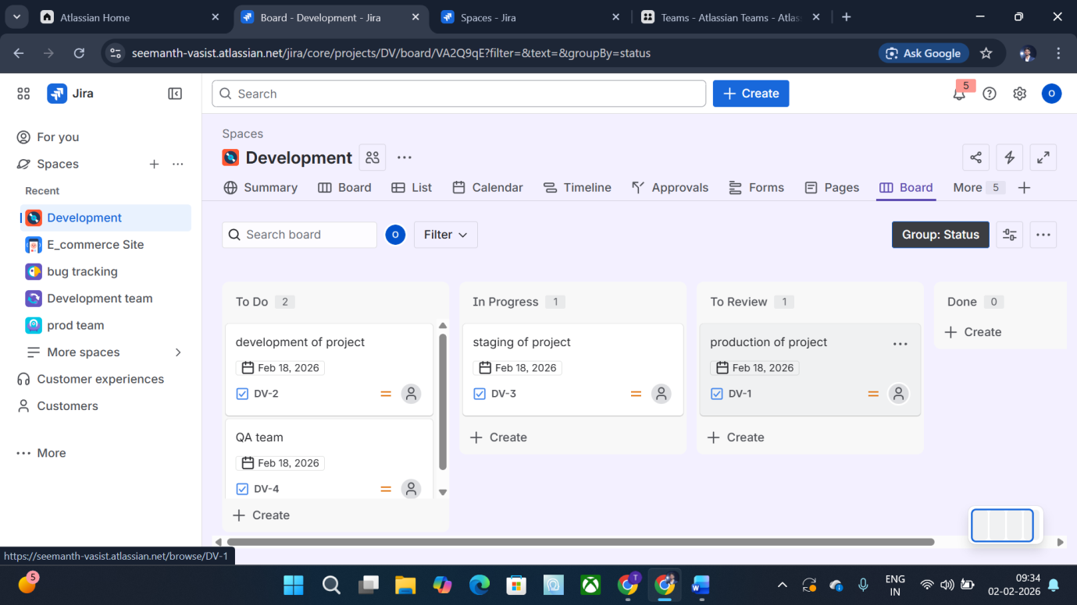

6. Approved → Move to DONE
- If everything is correct and approved, drag the task to DONE.
📌 Meaning: Task is fully completed and closed.

